**“IMRB”**

**SVN location for CHD**

**Course Path [SVN] \***

[http://192.168.2.4/content2016/IMRB/03_Project_Development/Construction/Media_Development/Build/Weighting and Projection Fundamentals/story.html](http://192.168.2.4/content2016/IMRB/03_Project_Development/Construction/Media_Development/Build/Weighting%20and%20Projection%20Fundamentals/story.html)

**Feedback sheet [SVN] \***

[http://192.168.2.4/content2016/IMRB/03_Project_Development/Construction/QC_Reports/External/Gold/IMRB_2 June.docx](http://192.168.2.4/content2016/IMRB/03_Project_Development/Construction/QC_Reports/External/Gold/IMRB_2%20June.docx)

**SB [SVN] \***

[http://192.168.2.4/content2016/IMRB/03_Project_Development/Construction/ID/Storyboards/IMRB_Weighting and Projection Fundamentals_SB.pptx](http://192.168.2.4/content2016/IMRB/03_Project_Development/Construction/ID/Storyboards/IMRB_Weighting%20and%20Projection%20Fundamentals_SB.pptx)

**Release notes:**

1. Scope of validation is **feedback sheet** only.
2. Check the course in all the 3 browsers **Chrome**, **Firefox** & **IE**.
3. Since we have changed the storyline version to **360**, so there might be some formatting issues. So please have a check to the complete course as well.
4. As per the client he is not able to move forward after he visit “**One variable**” section in the screen shown below in screenshot.
5. Please note menu is forced.
6. Tomorrow is the client delivery.
7. For any confusion please do connect before you start the validation.

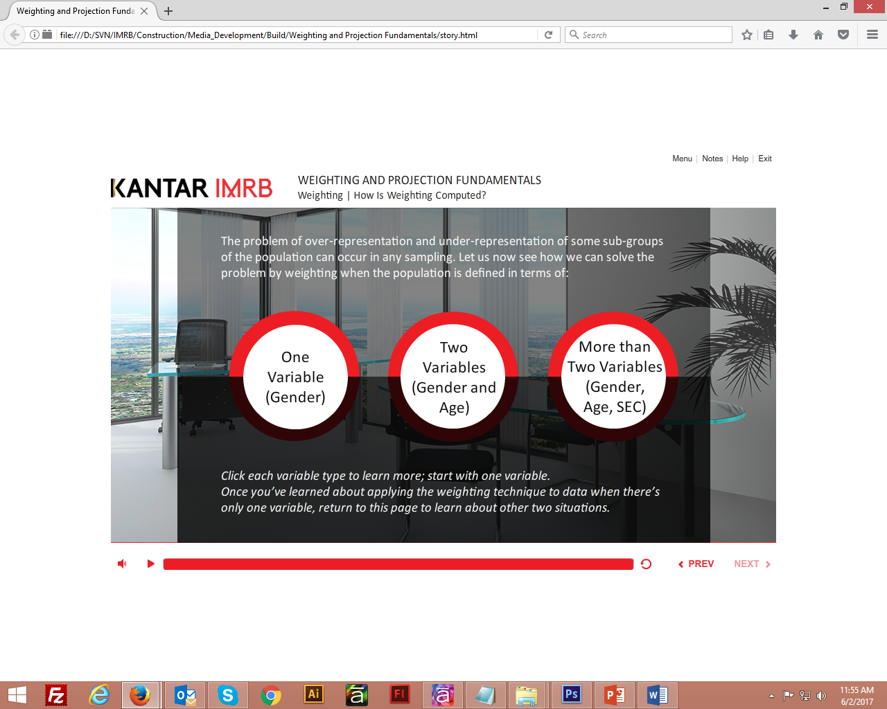

**Regards,**

**Neeraj Chauhan**

Sr. Graphic Designer | G-Cube Solutions

cid:image001.png@01D2DEB3.D13C7C00[neerajc@gc-solutions.net](mailto:neerajc@gc-solutions.net)

cid:image002.png@01D2DEB3.D13C7C00neerajc-gc

cid:image003.png@01D2DEB3.D13C7C00+91.120.4000.318 cid:image004.png@01D2DEB3.D13C7C00 9811321200

cid:image005.png@01D2DEB3.D13C7C00